2016

NCKU CSIE

Programming Design 2

Project_2 Report

|  |
| --- |
| MainWindow  +time_30: int  +x: int  +y: int  +position[15]: int  +score: int  +mark: int  +mark2: int  -ui: Ui::MainWindow |
| +timer: QTimer *  +timer_to_drum: QTimer *  +timer_to_cbg: QTimer *  +timer_to_cbg2: QTimer *  +Music: QMediaPlayer *  +Choosemode: QMediaPlayer *  +Easy: QMediaPlayer *  +Hard: QMediaPlayer *  +End: QMediaPlayer *  +HIT: QMediaPlayer * |
| <<constructor>> +MainWindow(parent: QWidget *)  <<destructor>> + ~MainWindow()  -on_Start_Button_Clicked()  -on_Press_To_Start_Easy_clicked()  -Game()  -showtime()  -slide_to_left()  -slide_to_right()  -keyPressEvent(event: QkeyEvent *)  -change_BG()  -change_BG2()  -on_Restart_Button_clicked()  -on_Exit_Button_clicked()  -on_Real_Button_clicked()  -on_Press_To_Start_Hard_clicked()  -on_Real_Button2_clicked()  -Game2()  -on_back_button_clicked()  -on_back_button2_clicked() |

UML

Screenshot

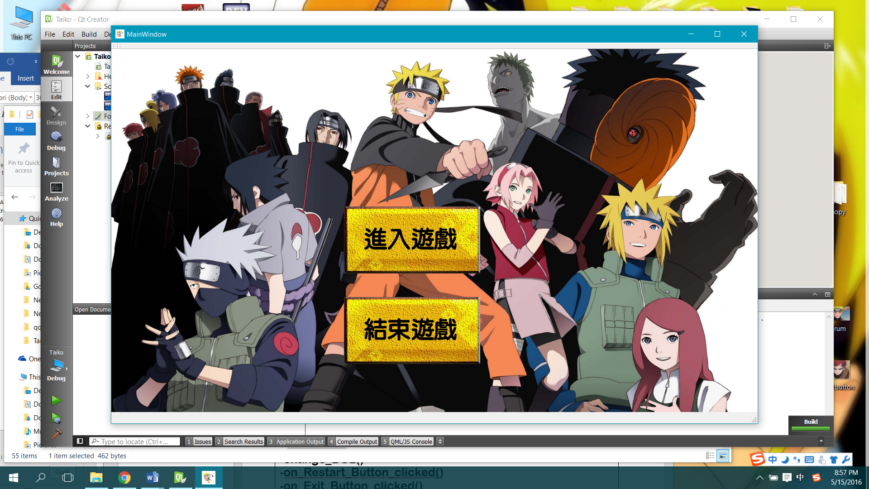Start Scene

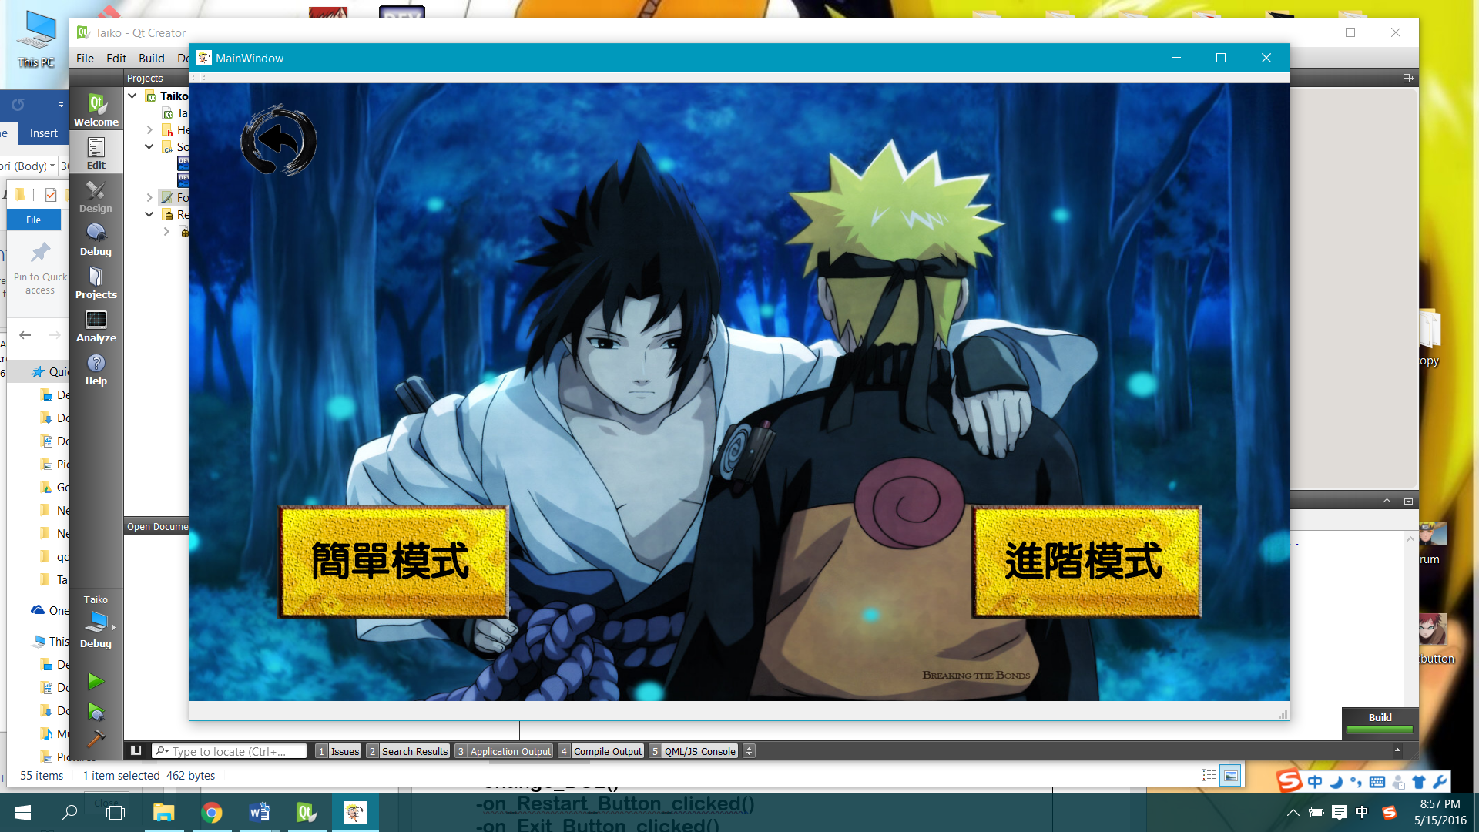Scene to choose playing mode

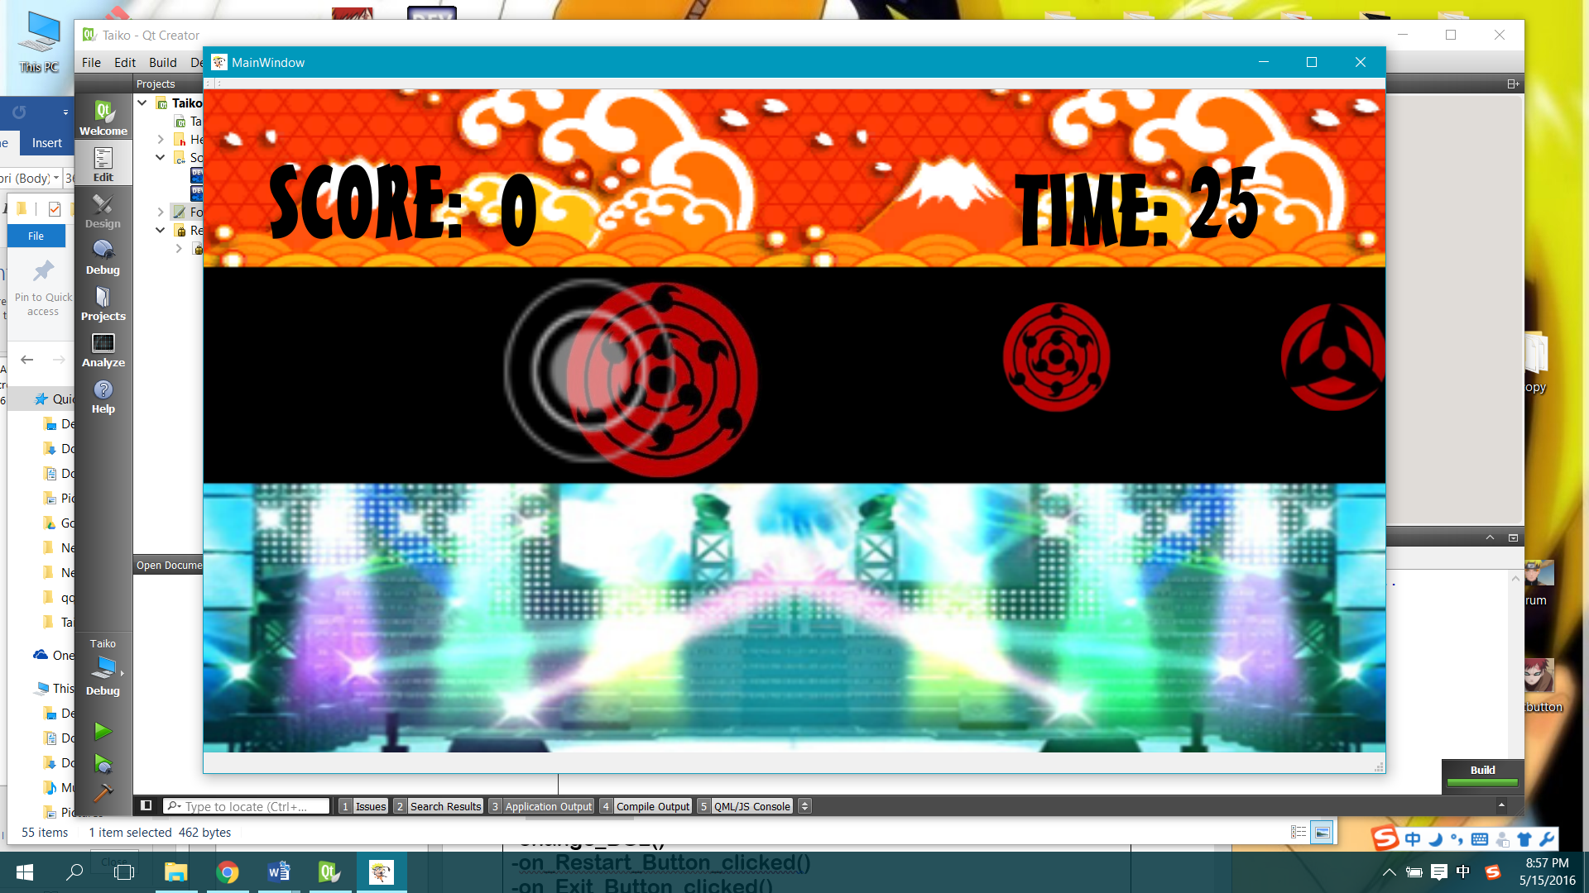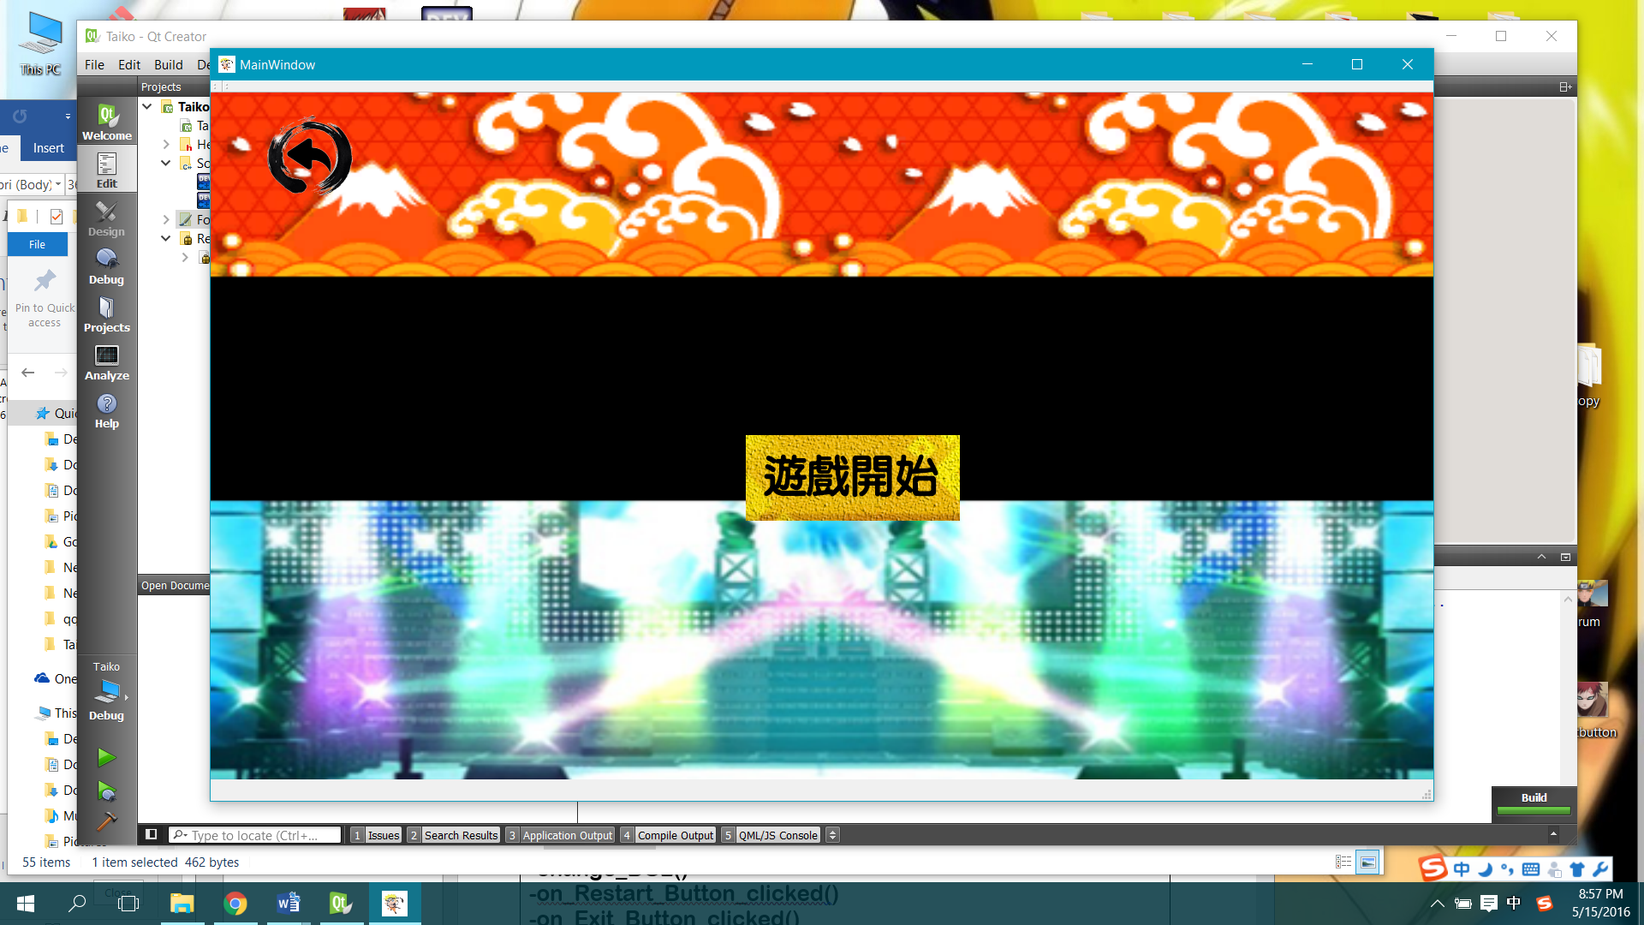Scene ready to start

Scene of the standard playing mode

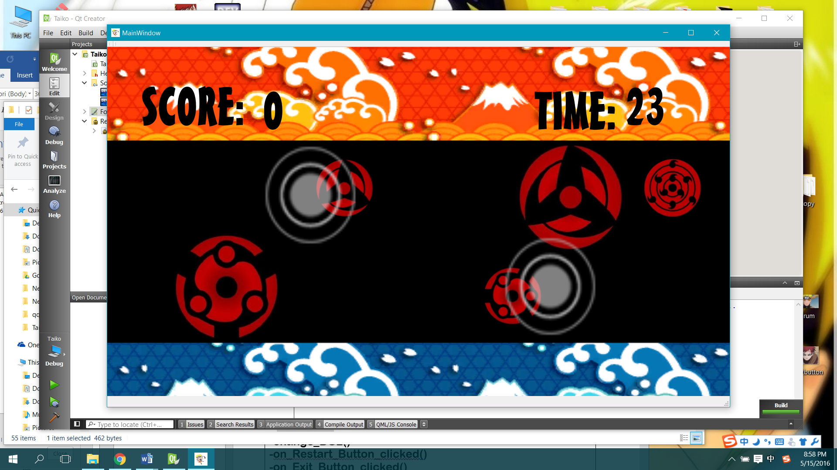Scene of the advanced playing mode

Scene of showing the score when the game ended

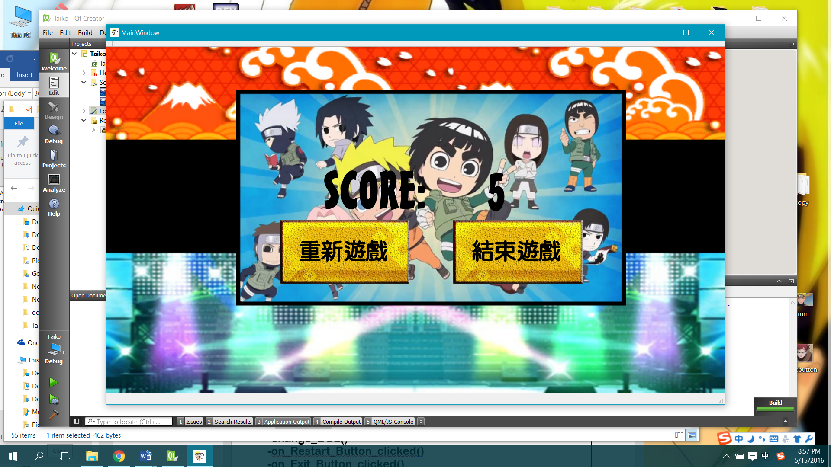

Program Architecture

MainWindow constructor

Every item included pictures, icons, sound effect, background music and buttons are declared here.

Game

There are two versions of playing which are the standard and advanced mode.

The drums are set at the left and right out of the showing scene.

The positions of the drums and the distances between the drums are set randomly.

The change in positions of the drums are connected to the timer which will change with certain time interval.

When the game starts, timer will be start to run and the positions of the drums will also be changed causing the drums to move.

Button L can be hit to score destroy the large drums.

Button S can be hit to score destroy the small drums.

Time limit to play a round of the game is 30 seconds.

Score will be shown when time’s out.

KeyPressEvent

Button L can be hit to score destroy the large drums.

Button S can be hit to score destroy the small drums.

There is a restriction to destroy the drums that positions of the drums have to at certain range which the target face at.

When the two situations are achieved, the drums are said to be destroyed and the positions are set randomly out of the scene again and the score will be increased.

ShowTime

It is connected to the timer, when the game starts and the timer starts to run, a variable, time_30, starts to change that decrease 1 by every second. When time_30 equals to 0, the game and the timer stop. The score is shown.

ChangeBG

Function change_BG() and function change_BG2() are connected to the timer that change the background with certain time interval

SlideToLeft/Right

Function slide_to_left() and function slide_to_right() are also connected to the timer to control the positions of the drums to move the drums and reset the positions of the drums.

OnButtonClicked

Every button have its own specific function.

Start_Button: to start the button

Press_To_Start_Easy: to play the standard playing mode

Press_To_Start_Hard: to play the advanced playing mode

Real_Start: start the game to count

Back_Button: back to the previous scene

Restart_Button: restart the game

Exit_Button: Exit the close the game